PRESS RELEASE | FOR IMMEDIATE RELEASE

04 June 2026
OpenSky World Partners with SolitAir to Strengthen Global North–Global South Air Cargo Connectivity
This collaboration will drive European market traction for SolitAir including Europe following its recent ACC3 designation for secure EU-bound cargo operations
Milan, Italy – OpenSky World has been appointed as CSA in Italy for SolitAir, the UAE’s dedicated B2B airport-to-airport express cargo airline. The strategic partnership will allow OpenSky World manage forwarder relationships, drive route-level commercial activity, and accelerate market entry for SolitAir across strategically vital European freight markets.
The collaboration marks a critical milestone for OpenSky World as it expands its international portfolio with a capacity-rich, agile partner operating at the crossroads of the world’s fastest-growing trade corridors. The appointment closely follows SolitAir’s acquisition of the ACC3 designation from the Belgian Civil Aviation Authority alongside EASA Third Country Operator (TCO) authorisation, which fully authorises the UAE carrier to operate secure cargo and mail services directly into the European Union.
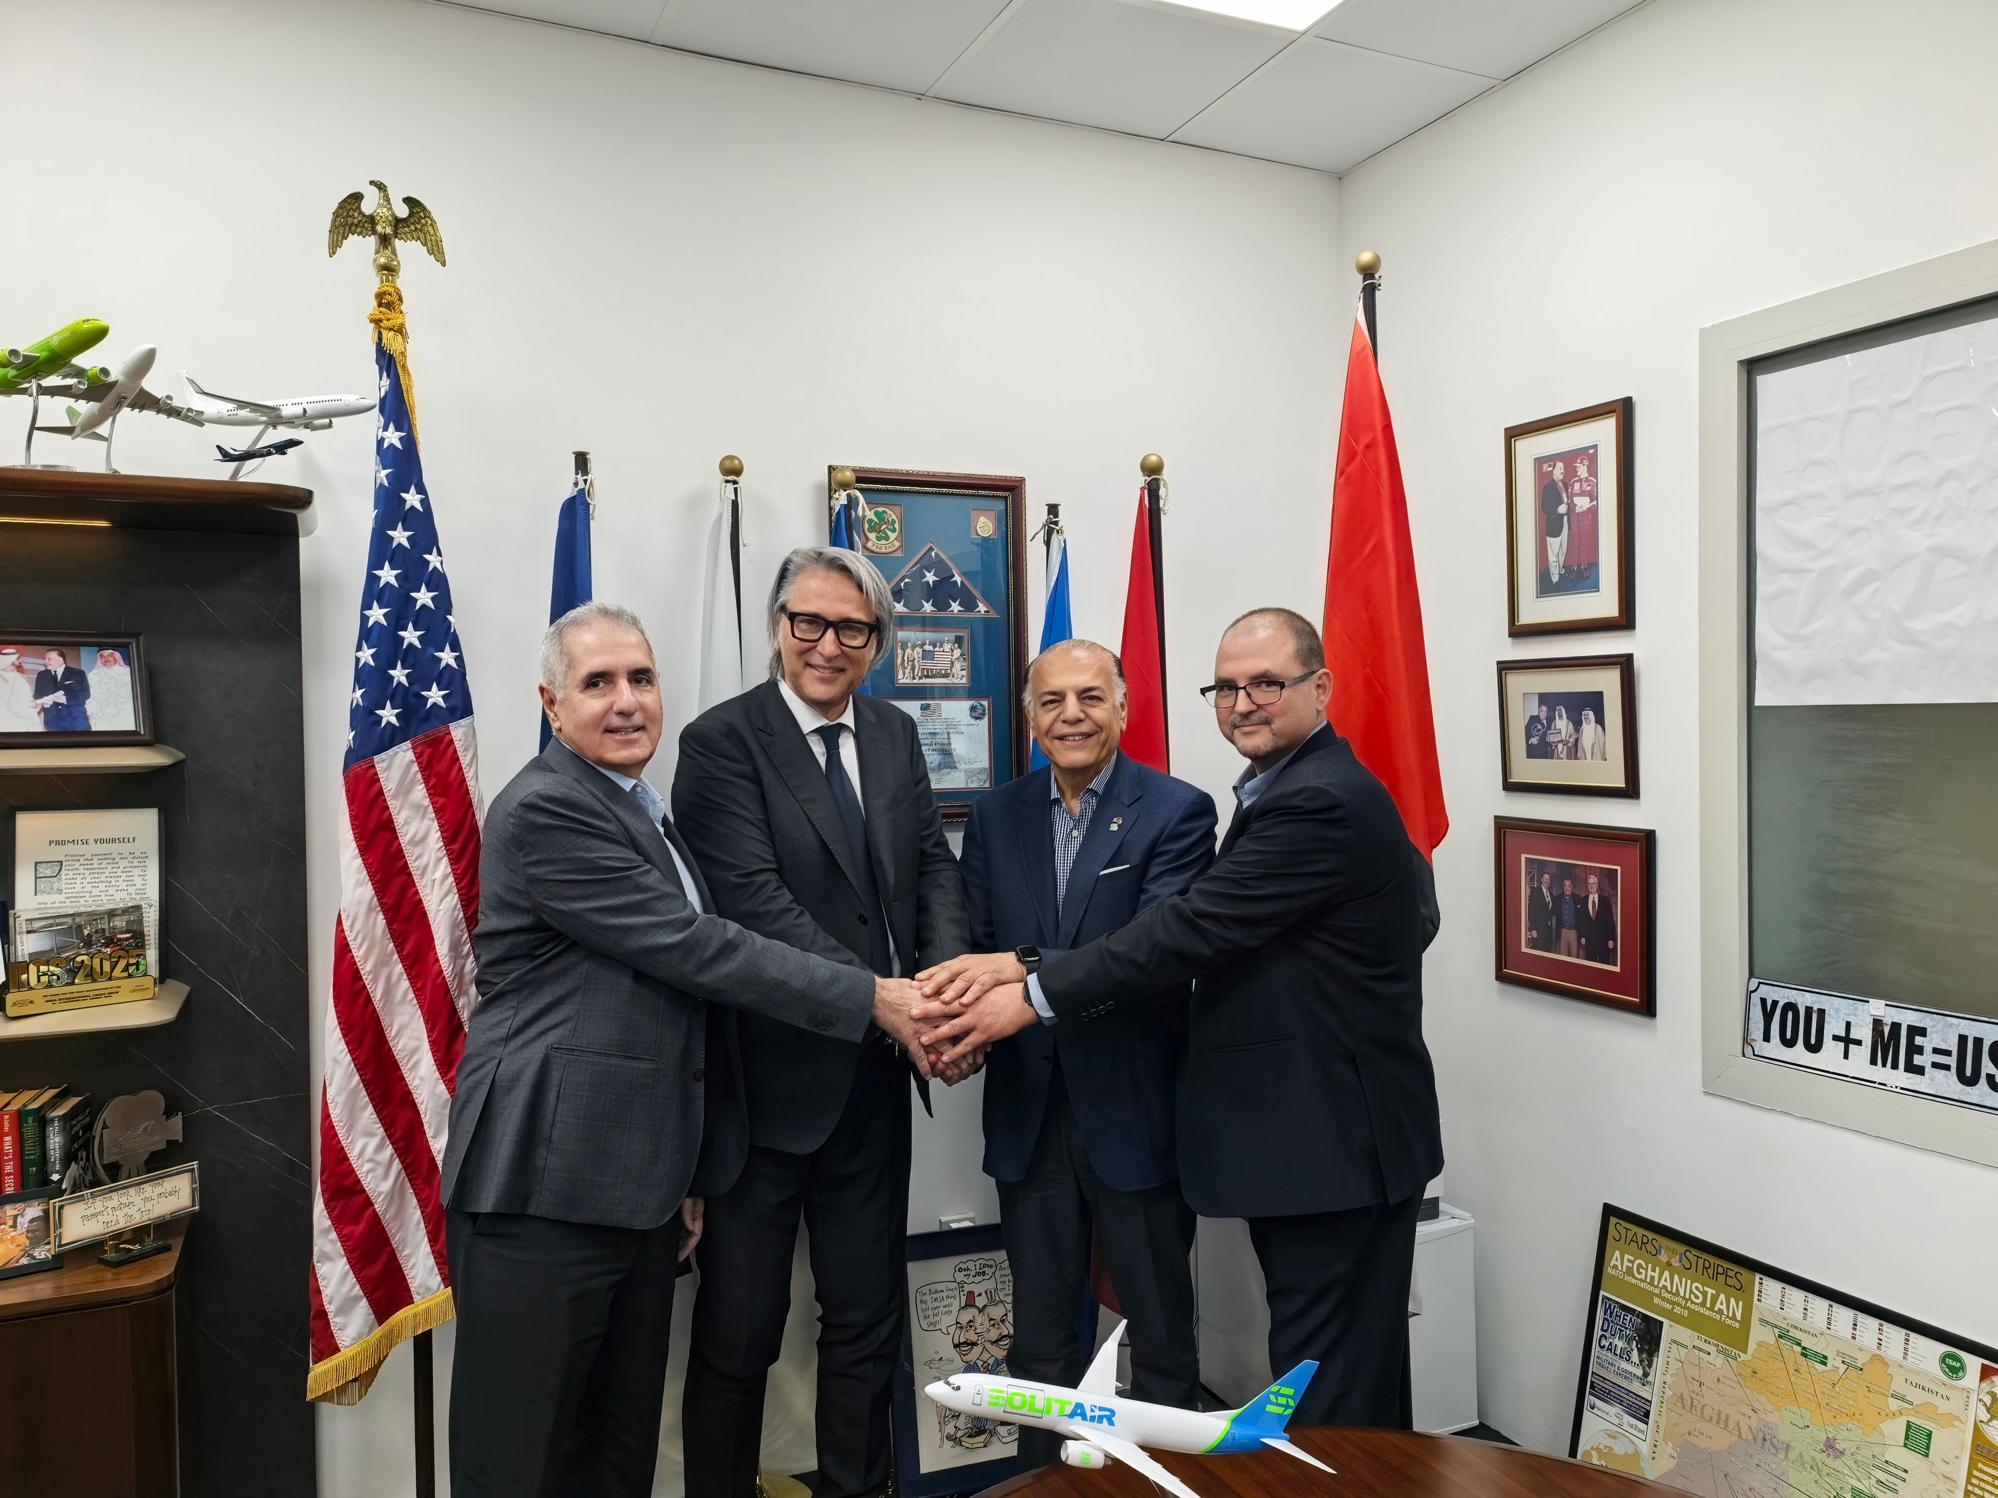
from Left to right:
Mr. Mazen Mamlouk, Chief Strategy Officer, SolitAir
Mr. Rossano De Luca, CEO, OpenSky World
Mr. Hamdi Osman, Founder & CEO, SolitAir
Mr. Norris El Hiraki, Director of Sales, SolitAir

“We are proud to support SolitAir as its Cargo Sales Agent in Italy. By leveraging our deep commercial roots — particularly throughout Europe — OpenSky World is positioned to connect the Global North and the Global South. This collaboration between SolitAir and OpenSky World creates significant opportunities for the development of new cargo routes and trade corridors, further strengthening connectivity between Europe, the Middle East, Africa, and Asia. These operations will not only reinforce international trade links, but also provide enhanced capacity, flexibility, and tailored solutions to meet the evolving needs of freight forwarders and logistics operators worldwide.", said Rossano De Luca, CEO, OpenSky World
The partnership introduces significant new capacity and flexibility to European logistics providers during a period of sustained structural reliance on air freight, driven by ongoing geopolitical volatility and global supply chain rerouting.
“This partnership represents not only an operational collaboration but also a long-term strategic alliance aimed at unlocking new business opportunities in the global air cargo sector. For European freight forwarders, it offers something additional to the market: a credible, capacity-rich, B2B-focused alternative on routes connecting Europe to the Gulf, Africa and beyond. " said Hamdi Osman, Founder & CEO, SolitAir. "OpenSky World, with its deep European commercial networks, will translate that capability into market traction - managing forwarder relationships, driving route-level commercial activity, and identifying where SolitAir’s offer is most compelling."
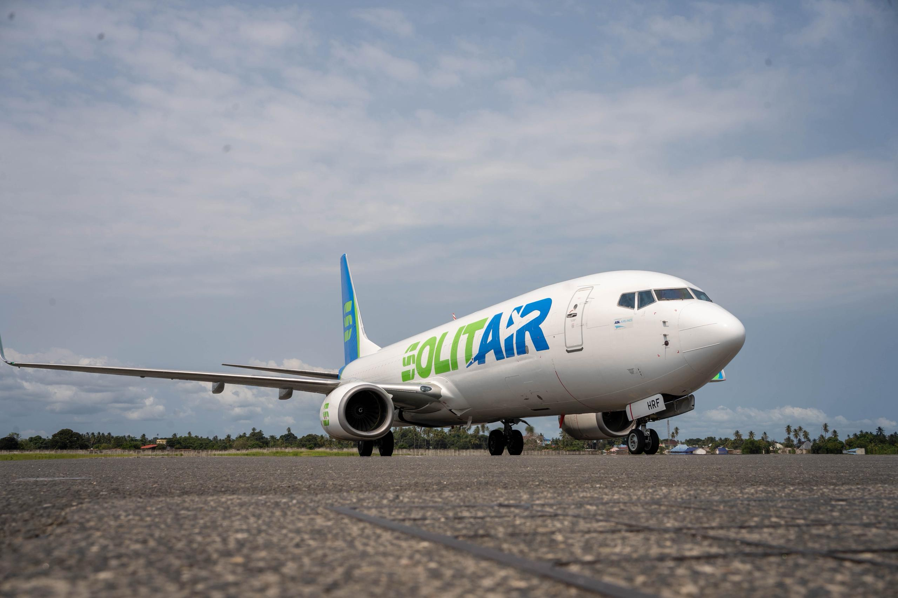
Launched from its Dubai World Central (DWC) hub in October 2024, SolitAir, is the UAE's dedicated B2B, airport-to-airport, express middle-mile cargo airline, enabling fast, reliable, and efficient movement of goods between key global trade hubs. In less than two years of operations, its network has grown to span over 50 routes across more than 30 countries, directly linking Dubai to major markets across the Middle East, Africa, the Indian Subcontinent, Central Asia, China, and now Europe. The carrier currently operates a fleet of seven Boeing 737-800 BCF freighters, with fleet expansion targeted at 14 aircraft by the end of 2026

Ends
About OpenSky World
OpenSky World is a well-established One-Stop-Shop company operating in the aviation industry, providing a wide range of services including Cargo and Passenger General Sales & Service Agent (GSSA) activities. With headquarters in Bologna and multiple cargo collection points across all Italy, the company focuses on market consolidation and development through tailored business plans and their effective implementation.
OpenSky World’s mission is to become a key strategic partner and “main player” for the airlines and companies it represents within the Italian market. A strong customer-oriented approach, combined with close cooperation and operational synergy with represented carriers, enables clients to perceive OpenSky World as a direct extension of the airline itself. The company ensures a dedicated commercial presence across the most important Italian regions, maintaining direct relationships with Civil Aviation Authorities, Airport Authorities and all customer segments in both cargo and passenger sectors, B2B and B2C, through a local and personalized approach.
The Chairman, Mr. Diego De Luca, started his career in the airline industry in 1965 and brings over 60 years of experience in both passenger and cargo aviation. His son, Rossano De Luca, has been active in the aviation sector since 1986, continuing the family’s long-standing expertise and international industry relationships.
About SolitAir
Headquartered at Dubai World Central (DWC), SolitAir is the next generation UAE's dedicated B2B, airport-to-airport, express middle-mile cargo airline, enabling fast, reliable, and efficient movement of goods between key global trade hubs. Operating 54 routes across 33 countries from its 20,440-square-metre logistics hub at DWC, SolitAir connects Dubai to major markets across the Middle East, Africa, the Indian Subcontinent, Central Asia, China, and Europe. Designed to complement freight forwarders, integrators, airlines, SMEs, and e-commerce businesses, SolitAir offers a flexible and customer-centric approach to air cargo logistics, achieving a 98%+ on-time delivery rate across its network. The airline's integrated platform spans four core service verticals — charters, programme services, scheduled flights, and ACMI — allowing tailored solutions across both high-demand and underserved routes. SolitAir is equipped to handle a wide range of cargo categories including Dangerous Goods, Pharmaceuticals, Perishables, Valuable Goods, Vulnerable Goods, Oversized Freight, and e-commerce shipments, and holds UAE GCAA Air Operator Certificate (AOC), Dangerous Goods Air Operator Certification, EASA Third Country Operator (TCO) authorisation, and ACC3 designation from the Belgian Civil Aviation Authority, authorising cargo operations into the European Union. It operates a modern fleet of seven Boeing 737-800 BCF freighters, with fleet expansion targeted at 14 aircraft by end of 2026 and 20 aircraft by 2027. Since its launch from DWC in October 2024, SolitAir has achieved key operational milestones ahead of schedule and earned multiple industry awards. Founded and led by Hamdi Osman — a logistics veteran with over four decades of experience, including 34 years as a senior executive at FedEx — the company is driven by a highly skilled leadership team with a combined 2,400 years of aviation and logistics experience.

For further information, please contact:
Rossano De Luca
CEO, OpenSky World
Cell: +39 335 1093525 | Email: rdl@openskyworld.it

